

**WEB BASED DOCUMENT CONTROL SYSTEM**

**(STUDY CASE: ANGKASA PURA I .LTD)**

**BIT305 FINAL YEAR PROJECT II**

E1400464 – Yoga Permana Tanaya

E1200241 – Aufar Rahman

Submitted to the

FACULTY OF COMPUTING AND DIGITAL TECHNOLOGY

(SCHOOL OF INFORMATION AND COMMUNICATION TECHNOLOGY)

In partial fulfilment of the requirements

for the degree of

BIT

HELP UNIVERSITY

SEPTEMBER 2017

## **Abstract**

Angkasa Pura I Ltd. is a company that manages airports in Indonesia. Angkasa Pura I Ltd. is divided into 2 (two) different companies based on the regulated airport area. Angkasa Pura I Ltd. manages airports in central and eastern Indonesia, while Angkasa Pura II Ltd manages airports in the western part of Indonesia. Both companies have many divisions. The division has been working in accordance with the respective responsibilities of which one of its divisions is the Quality Management Department. Quality Management Department is a division in Angkasa Pura I Ltd. Who has the responsibility in managing quality management at airports in Indonesia. These responsibilities include also in regulating the governance of documents in the company. At present the Quality Management Department manages the existing documents in this company in a manual way and inefficient manner, so that the chief of staff of the Quality Management Department plans to create an application system that allows to control this document to make paper more efficient, and improve the quality performance of the Quality Management Department itself. Documents managed by the company there are 2 types, there are internal and external. Internal documents such as Standard Operation Document, Work Instructions, and Company Manual, while external documents are documents that come from outside the company because Angkasa Pura I Ltd and Angkasa Pura II Ltd. Is a company managed by the government of the Republic of Indonesia then the documents from the government such as Regulation, etc. included in the external documents. The purpose of this system is to improve the performance of Quality Management Department itself and reduce the use of paper in the company in the document storage phase.

## **Declaration**

I hereby declare that the report presented here as part of the requirement of BIT304 is original and no parts of this report had been plagiarised from any other resources unless those indicated with proper referencing. This report will be the property of HELP University and cannot be distributed in any form without the written consent of HELP University.

Student Name: **Yoga Permana Tanaya**

Date: April, 14th 2018

Student Name: **Aufar Rahman**

Date: April, 14th 2018

**Acknowledgement**

This project will not be possible without the help of a number of people. We would like to express our deepest gratitude to the God, Our Parents, Our Siblings, and also Angkasa Pura I Ltd Company who has devoted much of his/her time to give permission to allow us to make this project.

# **Table of Contents**

Abstract 2

Declaration 3

Table of Contents 5

List of Tables 7

List of Figures 8

List of Symbols and Abbreviations 9

CHAPTER 1: PROPOSAL 10

1.1 Introduction 10

1.2 Company Background 10

1.3 Issues with Current System 11

1.4 Benefits and Constraints of Proposed System 11

1.5 Project Description 12

1.6 Project Aims and Objectives 12

1.7 Project Scope 12

1.8 Software and Hardware Requirements 13

1.9 Development Methodology 13

CHAPTER 2: LITERATURE REVIEW 14

2.1 Company Profile 14

2.2 Problem Statement 15

2.3 Proposed System 15

2.4 Development Model 16

2.5 Tools and Software 16

2.6 Summary 17

Reference 18

CHAPTER 3: PROJECT MANAGEMENT PLAN 19

3.1 Introduction 19

3.2 Work Breakdown Structure 19

3.3 Risks Management 20

CHAPTER 4: REQUIREMENTS ANALYSIS 22

4.1 Introduction 22

4.2 Requirements Summary 22

4.2.1 Functional Requirements 23

4.2.2 Non-Functional Requirements 23

4.3 Use Case Diagram 25

4.3.1 Admin’s Use Case 25

4.3.2 User’s Use Case 26

4.3.3 Extended Use Case 27

4.3.4 High-Level Use Cases 28

4.4 Database Design 34

4.5 Web Structural Design 35

4.5.1 User side 35

4.5.2 Admin Side 35

4.6 Interface Design 36

CHAPTER 5: ITERATIONS 37

5.1 Introduction 37

5.2 Iteration 1 37

5.2.1 Introduction 37

5.2.2 Purpose 38

5.2.3 Context 38

5.2.4 Schedule of Iteration Workflows 38

5.2.5 Iteration Schedule Breakdown 39

5.2.6 Resource Summary 39

5.2.7 Evaluation Criteria 40

5.2.8 Analysis and Design Artefacts 40

5.3 Implementation and Testing 41

5.4 Iteration Review and Evaluation 52

CHAPTER 6: CONCLUSION 53

6.1 Introduction 53

6.2 Further Improvement 53

6.3 Future Work 53

6.4 Project Evaluation 54

From : Yoga Permana Tanaya / E1400464 54

From : Aufar Rahman / E1200241 55

Bibliography 56

APPENDIX A: GANTT CHART 57

57

APPENDIX B: PROGRESS REPORTS 58

APPENDIX E: SYSTEM SUBMISSION 62

E.1 DVD 62

E.2 Installation Instructions 62

# **List of Tables**

Table 1 Software and Hardware Requirement 13

Table 2 Work Breakdown Structure 19

Table 3 Risk Management Plan 20

Table 4 Functional Requirement 23

Table 5 High Level Use Case 1 28

Table 6 High Level Use Case 2 28

Table 7 High Level Use Case 3 28

Table 8 High Level Use Case 4 29

Table 9 High Level Use Case 5 29

Table 10 High Level Use Case 6 29

Table 11 High Level Use Case 7 30

Table 12 High Level Use Case 8 30

Table 13 High Level Use Case 9 30

Table 14 High Level Use Case 10 31

Table 15 High Level Use Case 11 31

Table 16 High Level Use Case 12 31

Table 17 High Level Use Case 13 32

Table 18 High Level Use Case 14 32

Table 19 High Level Use Case 15 32

Table 20 High Level Use Case 16 33

Table 21 High Level Use Case 17 33

Table 22 High Level Use Case 18 33

Table 23 Iteration Plan 37

Table 24 Schedule of Iteration Workflow 38

Table 25 Iteration Schedule Breakdown 39

Table 26 Resource Summary 39

Table 27 Test Evaluation Report 41

# **List of Figures**

Figure 1 Gantt Chart 21

Figure 2 Admin Use Case 25

Figure 3 User Use Case 26

Figure 4 Extended Use Case 27

Figure 5 Database Design 34

Figure 6 User Web Structural Design 35

Figure 7 Admin Web Structural Design 35

Figure 8 User Interface Design 36

Figure 9 Admin Interface Design 36

Figure 10 Class Diagram 40

Figure 11 Admin and User Login Page 43

Figure 12 User Submission Form 43

Figure 13 User Fill the Support Document Form 44

Figure 14 Detail Document Page 44

Figure 15 User Fill the External Document Submission Form 45

Figure 16 User Dashboard Page 45

Figure 17 User Change Password Page 46

Figure 18 Add Document Category Page 46

Figure 19 Admin Dashboard 47

Figure 20 Admin Edit Document Form 47

Figure 21 User Edit Document Form 48

Figure 22 Document Successfully Updated 48

Figure 23 User And Admin Successfully Download Document Out From the System 49

Figure 24 Document Detail Page Between Internal Documents and Support Documents 49

Figure 25 An Alert When Admin When Press Delete a Document 50

Figure 26 Registration Page 50

Figure 27 Sorting Documents 51

Figure 28 Internal Document Report 51

Figure 29 External Documents Report 52

Figure 29 Burndown Gantt Chart 54

# **List of Symbols and Abbreviations**

PHP  Hypertext Preprocessor

SQL Standard Query Language

QM Quality Management

SOP Standard Operating Procedure

ICT Information Communication and Technology

RAD Rapid Application Development

# 

# **CHAPTER 1: PROPOSAL**

## **Introduction**

The Web Based Document Control System is a project currently being developed by Angkasa Pura I Ltd. This project aims to control, sort and manage documents both external and internal that exist in the company. This project has coincidentally been developed by one of our member team when doing internship work in this company. This system will be developed using web based platform where all documents that exist in this company will be managed through this system. The documents that could be managed like SOP (*Standard Operating Procedure)* Document, IK (*Intruksi Kerja)* Document, and some regulation from outside of this company that can be called external document.

## **Company Background**

Angkasa Pura I Ltd. is a company that manages airports in Indonesia. Angkasa Pura I Ltd. is divided into 2 (two) different companies based on the regulated airport area. Angkasa Pura I Ltd. manages airports in central and eastern Indonesia, while Angkasa Pura II Ltd manages airports in the western part of Indonesia. This project belongs to the Angkasa Pura I Ltd but if this project is successful, later it will be implemented in Angkasa Pura II Ltd too.

## **Issues with Current System**

Management of Angkasa Pura I Ltd. is divided into several departments. Each department is responsible for their respective duties to manage this company. One of the divisions in this company is Quality Management Department which is responsible for management in terms of quality of service available at every airport in Indonesia. Each department in Indonesia has a responsibility to create a document. The documents may be internal documents for company purposes such as SOP, IK documents or external documents such as Regulations of Republic Indonesia documents. Each document both internal and external must go through the verification stage of the Quality Management Department deciding whether the document is eligible for use or not, whether revised or valid. The revised document shall be re-amended by the relevant departmental employee who filed the document and if the document is valid (no revision required) the document is placed in the archive room.

## **Benefits and Constraints of Proposed System**

The end users of the system are all employees in Angkasa Pura I Ltd. The admin will be the Quality Management Department staff. The benefits if this project is implemented, the company will improve work on Quality Management Department, more efficient work and the more important point is the company will have digital library to store their document, so there will be no need to use a lot of paper (paperless).

The output that we expected from this project is a web based system that could store many documents of Angkasa Pura Ltd. The Quality Management Department Staff could track the document easily by this system.

## **Project Description**

Departing from this case study we will create a system that allows internal or external documents to be manage online through the system we created. The admin of this system is the Quality Management Department staff itself while the user is a staff of other Departments other than Quality Management Department.

## **Project Aims and Objectives**

The real purpose of making this application is to break the distribution chain of documents in this company. Not too many papers need to be printed only for one process of document creation and revision is needed. Besides, other objectives of this project are as follows

* Improvement on Quality Management Department
* Improve work efficiency
* Reduce corporate spending and support Go Green program from the Angkasa Pura I Ltd.
* Facilitate to be easily accessed documents

## **Project Scope**

This project is a web-based application that we designed for use by internal company the Angkasa Pura I Ltd. This system works to facilitate the control and accessing archives in this company. All files in softcopy will be stored on a server. Restrictions that exist in this system is that this system will not be generally accessible bias because it requires authentication by using a username and password that will only be owned by employees of this company. Making username and password later can only be done by the staff of QM Department as the admin of this application. End users of this application are all employees of all departments in this company.

## **Software and Hardware Requirements**

Table 1 Software and Hardware Requirement

|  |  |  |  |
| --- | --- | --- | --- |
| **Work** | **Hardware & Tools** | **Software** | **Qty** |
| Requirement analysis | Pencil or pen and Paper |  |  |
| Making database | Laptop | SQL Yogg | 1 |
| Design and Coding | Laptop | Sublime text 3 | 1 |
| Deployment | Laptop |  | 1 |
| Testing | Laptop | Apache Server (XAMPP),  Google Chrome  Mozilla Firefox | 1 |
| Document plan writing |  | Microsoft Word 2016 | 2 |
| Preparing gantt chart | Laptop | Gantt project | 2 |
| Prepare the back-end | Laptop | Codeigniter 3 Framework | 1 |
| Prepare the front-end | Laptop | An admin bootstrap template | 1 |
| Print all documents | Printer |  | 1 |

## **1.9 Development Methodology**

The methodology we will use in developing this system is Rapid Prototyping in software development, when a small team quickly builds a working software program for users to review. It is also called rapid prototyping. It may also be called Rapid Application Development ([RAD](http://searchsoftwarequality.techtarget.com/definition/rapid-application-development)). Rapid Application Development is a methodology of software development that allows to develop projects with project resources that have been done before. One of our team members is used to developed this kind of software when he got an internship assignment in this company. So we just need to continue the work that has been completed by one of our team.

# 

# 

# **CHAPTER 2: LITERATURE REVIEW**

### **2.1 Company Profile**

### 

Angkasa Pura I Ltd. is a company that manages airports in Indonesia. Angkasa Pura I Ltd. is divided into 2 (two) different companies based on the regulated airport area. Angkasa Pura I Ltd manages airports in central and eastern Indonesia, while Angkasa Pura II Ltd manages airports in the western part of Indonesia. Angkasa Pura I Ltd has many department in it. Each of the department has responsibility according to their respective fields. Currently Angkasa Pura I Airports manages 13 (thirteen) airport spread in all over middle and east Indonesia region. Beside that Angkasa Pura Airports has many subordinate company that manages which has different business field there are:

1. Angkasa Pura Logistic Ltd. manage all the logistic needs for the airports
2. Angkasa Pura Property Ltd manage all the property asset for the airports in a region in Indonesia. Like land and building
3. Angkasa Pura Support Ltd manage all the outsourcing labor that worked in airport
4. Angkasa Pura Hotel Ltd manage the Novotel. Novotel is a trademark that currently as the brand of the hotel that manage by Angkasa Pura Airports
5. Angkasa Pura Retail Ltd manage the shop and stand in the airports

Base on the Indonesia Government regulation rule 5 year 1992. The market shares of Angkasa Pura Company belongs to Indonesia Government. Because of this Angkasa Pura Company is named Angkasa Pura Ltd. Ltd means Limited or in Indonesia it is called *PT (Perseroan Terbatas)*. The history of Angkasa Pura Airports began since 1962. On that year the first Indonesia President Ir. Soekarno back from United States. He ordered the Minister of Transportation in that era to make Airport in Indonesia. Base on that idea came out The Government Rule *(PP)* Number33 Year 1962 about the starting of the milestone the built of National Company *(PN)* and the name on that day was Angkasa Pura Kemayoran, Jakarta. That has responsibility to manage airport in Kemayoran, Jakarta that was the first and one and only airport that had services for domestic and international flight in that era (Angkasa Pura 1, n.d.).

### **2.2 Problem Statement**

In this company each staff in all department had responsibility to make achieve or document for their department. The achieve would be internal or external. The internal achieve usually for internal use in this company and external achieve usually comes from outside of the company like regulation from the government of Indonesia. All achieve in this company must be verified first by QM staff and if the achieve is not valid the staff that makes the achieve must do revision until the QM staff stated that achieve is valid. This process is done manually by all staff and QM staff as the verifier of the achieve. According to Eirene one of QM staff said it needs ±12 days of working process with the current system.

### **2.3 Proposed System**

From the problem statement above we propose a web based application to solve the problem in this company. The system will be can manage the achieve in this company starts from submitting the achieve, revision, until the QM staff can state the achieve is valid. Why web based application? Because every department room in this company is connected with a network and the company itself had a server. The web application itself will had 2 (two) actor in it. The admin of the system will be the QM staff and the user is all staff in all department in this company.

### 

### **2.4 Development Model**

The development model we used for the making of the system is RAD. As said by James Martin with the same title (Martin, 1992) RAD is a methodology of software development lifecycle to give a faster development and higher quality result (Beynon-Davies, 1999). Why we use RAD as our development model because one of our team member had done a similar system with the system we proposed here. So if we used RAD development it could reduce time saving in development cause we must not scratch from the beginning in coding.

### **2.5 Tools and Software**

The programming language that we have choose to develop the system is PHP. PHP is a simple yet powerful language designed for creating HTML content. (R Lerdorf, 2006).

PHP can be used in 3 (three) ways there are:

1. Server-side scripting
2. Command-line scripting
3. Client-side GUI application

Not only PHP. We used a framework too in the making of the system. The framework that we have used is Codeigniter framework with version 3. The reason why we used PHP framework over a procedural PHP can be answered based on a study that has been conducted in which two functionally equivalent blogging web applications have been developed and subjected to an experiment in which the performance of each of the mentioned frameworks is measured and evaluated. The first web application will be developed in plain PHP. The other one will be developed in the PHP framework CodeIgniter. After implementing the applications, performance metrics are measured on all these versions of the web application. These measurements will consist of (i) Execution time of CRUD-functionality (ii) Memory usage for each of them. The results from the experiments are analyzed and interpreted in order to become the basis of the decisions and conclusions of this study (Das, 2016). The Database that we used in the development of the system is My SQL. My SQL is the world’s most popular open source database. My SQL now currently owned by Oracle delivering new capabilities to power next generation web, cloud, mobile and embedded applications (Oracle, n.d.). We use Apache as our web server. The Apache HTTP Server ("httpd") was launched in 1995 and it has been the most popular web server on the Internet since April 1996. It has celebrated its 20th birthday as a project in February 2015 (APACHE, n.d.).

### **2.6 Summary**

Angkasa Pura I Ltd has many department that had responsibility in manage airport in Indonesia. Each of the department has responsibility according to their respective fields.

Currently Angkasa Pura I Ltd manage entire achieve or document manually by QM Department and it needs at least 12 days of work to verify document for each staff that doing submission.

As the problem statement explained before we proposed a web application system that could make QM staff work easily and efficiently using this proposed system.

The methodology of the system that we proposed is RAD. Because one of our member had done the similar system when doing internship in this company.

The programming language that we use in development of this system is PHP because it is yet powerful language that could run on server side. And as the database we use MySQL because it has capabilities to power next generation web, cloud, mobile and embedded applications. We also used Apache as our web server to run the system.

The result of the system that we proposed is finally meet the company expectations. At the end of the development we must make ensure that the system we proposed here can be deployed and work well in the server of this company owned.

### **Reference**

Angkasa Pura 1. (n.d.). *AngkasaPura Airports* . (AngkasaPura Airports ) Retrieved from AngkasaPura Airports : https://www.ap1.co.id/id/about/our-history

Kenny, E. (2017). *SISTEM PENYEDIAAN DOKUMEN INTERNAL DAN EKSTERNAL .* Badung: Angkasa Pura I Persero .

Beynon-Davies, P. C. (1999). Rapid application development (RAD): an empirical review. *European Journal of Information Systems*, 211-223.

R Lerdorf, K. T. (2006). *Programming Php.* O'Reilly Media, Inc.

Das, R. S. (2016). Comparison of Procedural PHP with Codeigniter and Laravel Framework. *International Journal of Current Trends in Engineering & Research*, 2(6).

Dubois, P. (2003). *MySQL: the definitive guide to using, programming, and administering MySQL 4.* Sams.

*Definition - What Does Structured Query Language (SQL) mean?* (n.d.). Retrieved from techopedia : https://www.techopedia.com/definition/1245/structured-query-language-sql

Oracle. (n.d.). *About MySQL*. Retrieved from MySQL: https://www.mysql.com/about/

APACHE. (n.d.). Retrieved from APACHE HTTP SERVER PROJECT.

Kenny , E. (n.d.). SISTEM PENYEDIAAN DOKUMEN INTERNAL DAN EKSTERNAL . Badung, Bali, Indonesia .

# **CHAPTER 3: PROJECT MANAGEMENT PLAN**

## **3.1 Introduction**

This system works to facilitate the control and access archives in the company. All files in softcopy will be stored on a server. Restrictions that exist in this system is that this system will not be generally accessible because it requires authentication by using a username and password that will only be owned by employees of this company.

## **3.2 Work Breakdown Structure**

Table 2 Work Breakdown Structure

|  |  |  |  |  |
| --- | --- | --- | --- | --- |
| Activity | Priority (Low =1,  High=5) | State | Assigned to | Effort Estimated (Days) |
| Identify project background | 1 | Closed | All member | 1 |
| Identify project aims | 1 | Closed | All member | 1 |
| Identify methodology | 1 | Closed | Yoga | 1 |
| Identify technique | 1 | Closed | Yoga | 1 |
| Develop gantt chart | 2 | Closed | All member | 2 |
| User requirement analysis | 3 | Closed | All Member | 2 |
| Develop manual system flowchart | 3 | Closed | Yoga | 3 |
| Develop application system flowchart | 3 | Closed | Yoga | 3 |
| Develop Use case diagram | 3 | Closed | Aufar | 3 |
| Develop database design | 4 | Closed | Yoga | 2 |
| Develop web structural design  (Front-end & Back-end) | 4 | Closed | All member | 9 |

## **3.3 Risks Management**

Table 3 Risk Management Plan

|  |  |  |  |  |
| --- | --- | --- | --- | --- |
| **No.** | **Description** | **Probability**  **%** | **Impact**  **Low=1**  **High=5** | **Mitigation Strategy** |
| 1. | Of our team members have little knowledge in using programming language especially in PHP and the framework to make this project easily. | 50 | 5 | Look for references from available resources such as internet article, websites, and practice ourselves or ask to friends and programmers. |
| 2. | Absence of team member in a meeting because of sick or another reason at critical times in the project. | 30 | 3 | Allocate the task to the available member in order to avoid delays |
| 3. | Data lost and/or system crash due to unexpected circumstances. | 30 | 5 | Back up all data and all members must have the copy of each works. |
| 4. | Misscommunication regar ding issues of the project. | 50 | 4 | Keep updated and maintain the communication with all team members. |

**3.4 Gantt Chart**

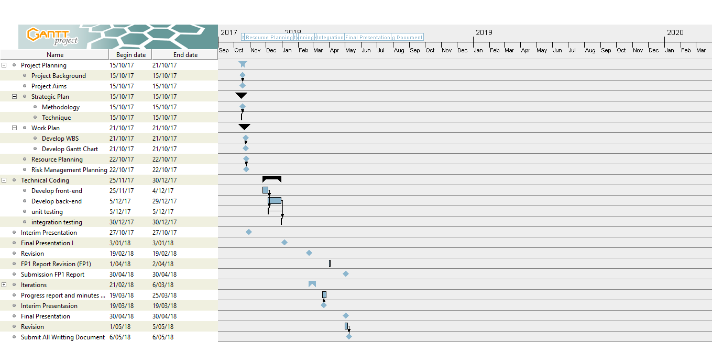

Figure 1 Gantt Chart

# **CHAPTER 4: REQUIREMENTS ANALYSIS**

### 

## **4.1 Introduction**

At this stage we analyze the needs of the system. Where the results of the activities in the form of use case, extended use case and class diagram of the system. We did prototyping with ICT staff from this company who also provided us with flowcharts to help us understand the system workflow manually. Workflow is done manually where the process starts from every employee to make a document The documents is sent to the QM Department to check whether it has been appropriate or not If not then the employee must do the editing of documents. After the editing process if the document is considered valid by the Quality Management Department then the document is distributed to each division and then is used as appropriate by the division of the employees who submit the document

## **4.2 Requirements Summary**

This system will have an end user who is an employee of each division in this company. Admin of this system is a staff of Quality Management Department in this company. The function we want to achieve from the system is this system is able to work like a document library for the company so as to cut the excess of the process of printing documents from the Quality Management Department to each division that filed the documents. And admin here can easily do document numbering and document editing.

### 

### **4.2.1 Functional Requirements**

We has been summarize the functional requirements of the system by using this table below between admin and user.

Table 4 Functional Requirement

|  |  |
| --- | --- |
| Admin | User |
| Resubmit Documents / Achieve | Submit Documents / Achieve |
| Edit Documents | Edit Documents |
| Resubmit SupportAchieve | Submit Support Documents |
| Edit Support Achieve | Edit Support Documents |
| Delete Support Achieve | 🗶 |
| Delete Document | 🗶 |
| Make report | 🗶 |
| Download Document | Download Document |
| Resubmit External Document | Submit External Document |
| Edit External Document | Edit External Document |
| Delete External Document | 🗶 |
| Login | Login |
| Logout | Logout |
| Register Admin | 🗶 |
| Register User | 🗶 |
| Change Password | Change Password |
| Sort Documents | Sort Documents |
| Verify Documents | 🗶 |

### **4.2.2 Non-Functional Requirements**

**Technical Requirements**

This system will be implemented on a web-based. Of course it requires an apache or nginx server to run it from the server side. From the client side it only takes a web browser to run it for our OS (Operating System). The developer does not provide any restrictions on the OS that can be used from the client side because the application-based can run on all origin OS have Web Browser (eg Google Chrome, Mozilla FireFox, Safari etc.)

**Usability Requirements**

Our system uses a responsive user interface so that it can adapt to various devices (mobile, table, or PC) We also put on the logo of the respective company Angkasa Pura I Ltd on the logo in our application because this application if it has been completed it will belong to the company.

**Reliability Requirements**

Constraints that may arise from this application is the ability of the server to serve the service of the client because the more requests from the client to access this application then the loading will be more severe it has been overcome by this company where Angkasa Pura Ltd has many server

**Security Requirements**

Because our web-based system which in this case rely on client and server then the security factor is definitely become the main in the system that we make. Because in this system will be stored many important documents there may be a confidential property of this company.

## 

## **4.3 Use Case Diagram**

## **4.3.1 Admin’s Use Case**

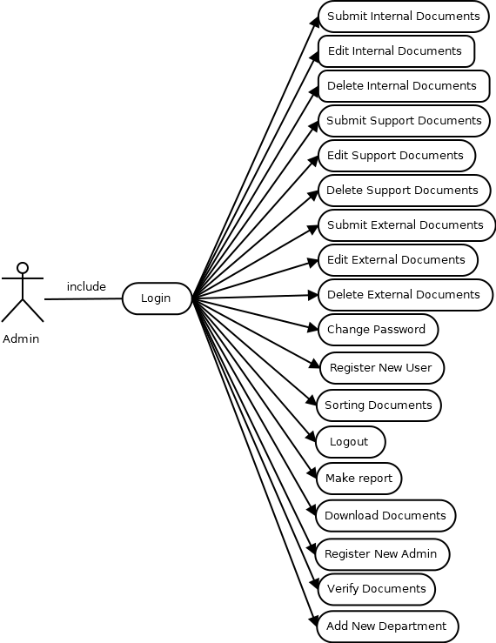

Figure 2 Admin Use Case

## **4.3.2 User’s Use Case**

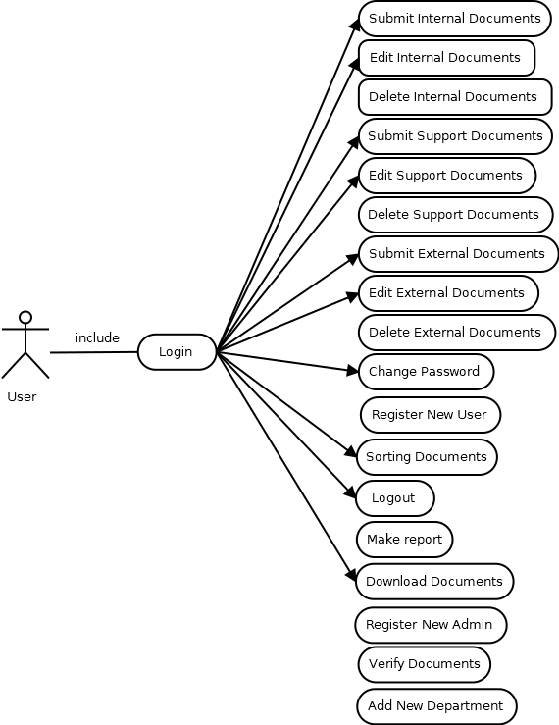

Figure 3 User Use Case

## **4.3.3 Extended Use Case**

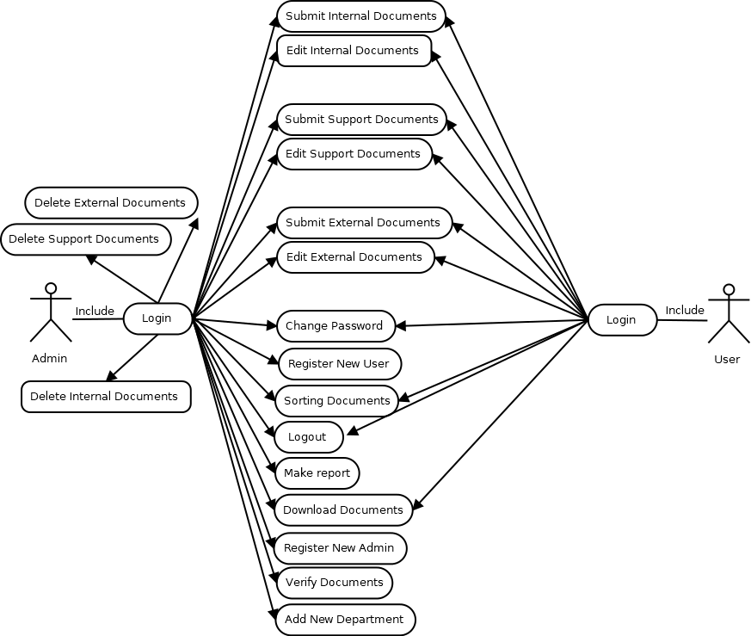

Figure 4 Extended Use Case

## **4.3.4 High-Level Use Cases**

Table 5 High Level Use Case 1

|  |  |
| --- | --- |
| **Use Case 1[1]** | Submit Internal Document |
| Goal in Context | User and admin could upload internal document to the system |
| Primary Actor | User |
| Secondary Actor | Admin |
| Description | User upload internal document to the system. Admin can resubmit the internal document that have been uploaded by the user before |

Table 6 High Level Use Case 2

|  |  |
| --- | --- |
| **Use Case 2**[2] | Edit Internal Document |
| Goal in Context | User can edit internal document base on the note that given by admin |
| Primary Actor | User |
| Secondary Actor | Admin |
| Description | User and admin can edit the existing internal document and re upload the new internal document to the system |

Table 7 High Level Use Case 3

|  |  |
| --- | --- |
| **Use Case 3**[3] | Delete Internal Document |
| Goal in Context | Admin can delete the Internal Document |
| Primary Actors | Admin |
| Description | Admin can delete each internal document that has been uploaded in the system |

Table 8 High Level Use Case 4

|  |  |
| --- | --- |
| **Use Case 4**[4] | Submit External Document |
| Goal in Context | User or admin can submit external document to the system |
| Primary Actor | User |
| Secondary Actor | Admin |
| Description | User or admin can upload external document to the system. Admin here as the validator |

Table 9 High Level Use Case 5

|  |  |
| --- | --- |
| **Use Case 5**[5] | Edit External Document |
| Goal in Context | User or admin can edit external document in the system |
| Primary Actor | User |
| Secondary Actor | Admin |
| Description | User and admin can resubmit the external document that has been updated |

Table 10 High Level Use Case 6

|  |  |
| --- | --- |
| **Use Case 6**[6] | Delete External Document |
| Goal in Context | Admin can delete the external Document |
| Primary Actors | Admin |
| Description | Admin can delete each external document that has been uploaded in the system |

Table 11 High Level Use Case 7

|  |  |
| --- | --- |
| **Use Case 7**[7] | Submit Support Document |
| Goal in Context | User or Admin can Submit Support Document to the system |
| Primary Actor | User |
| Secondary Actor | Admin |
| Description | User can make a link document between internal document and this support document |

Table 12 High Level Use Case 8

|  |  |
| --- | --- |
| **Use Case 8**[8] | Edit Support Document |
| Goal in Context | User or Admin can Re submit Support Document to the system |
| Primary Actor | User |
| Secondary Actor | Admin |
| Description | User and admin can edit the support document |

Table 13 High Level Use Case 9

|  |  |
| --- | --- |
| **Use Case 9**[9] | Delete Support Document |
| Goal in Context | Admin can delete Support Document from system |
| Primary Actor | Admin |
| Description | Admin can delete support document from the system with the file in the system itself |

Table 14 High Level Use Case 10

|  |  |
| --- | --- |
| **Use Case 10**[10] | Sort Document as type |
| Goal in Context | Document can be sorted as its type |
| Primary Actors | User and admin |
| Description | User and admin both can sort documents as category |

Table 15 High Level Use Case 11

|  |  |
| --- | --- |
| **Use Case 11**[11] | Edit Profile |
| Goal in Context | User can edit their username or password |
| Primary Actors | User and admin |
| Description | User and admin edit their username or password |

Table 16 High Level Use Case 12

|  |  |
| --- | --- |
| **Use Case 12**[12] | Registration |
| Goal in Context | User can do a registration to create an account to use the system |
| Primary Actors | User and admin |
| Description | User and admin can do a registration to create an account to use the system |

Table 17 High Level Use Case 13

|  |  |
| --- | --- |
| **Use Case 13**[13] | Approving Document |
| Goal in Context | Admin can decide what document need to approve |
| Primary Actors | Admin |
| Description | Admin can re submit the valid document to the system with .pdf format (un editable) |

Table 18 High Level Use Case 14

|  |  |
| --- | --- |
| **Use Case 14**[14] | Login |
| Goal in Context | Admin or User can login before using the system |
| Primary Actors | Admin and User |
| Description | Admin or user can input their username and password to login before using the system |

Table 19 High Level Use Case 15

|  |  |
| --- | --- |
| **Use Case 15**[15] | Logout |
| Goal in Context | Admin or User can logout after using the system |
| Primary Actors | Admin and User |
| Description | Admin or user can logout after using the system |

Table 20 High Level Use Case 16

|  |  |
| --- | --- |
| **Use Case 16**[16] | Make Report |
| Goal in Context | Admin can make a printout of document details that already submitted from all user |
| Primary Actors | Admin |
| Description | Admin can print a report with excel format (.xls) as the report of document details that already submitted from all user |

Table 21 High Level Use Case 17

|  |  |
| --- | --- |
| **Use Case 17**[17] | Download Document |
| Goal in Context | Admin or User can download each document out from the system |
| Primary Actors | Admin and User |
| Description | Admin and user can download each document internal, external or support document out from the system |

Table 22 High Level Use Case 18

|  |  |
| --- | --- |
| **Use Case 18**[18] | Add New Department |
| Goal in Context | Admin can add new department / division |
| Primary Actors | Admin |
| Description | Admin can add new division / department that can be used by the user to differentiate their account from the admin division (QM) |

## **4.4 Database Design**

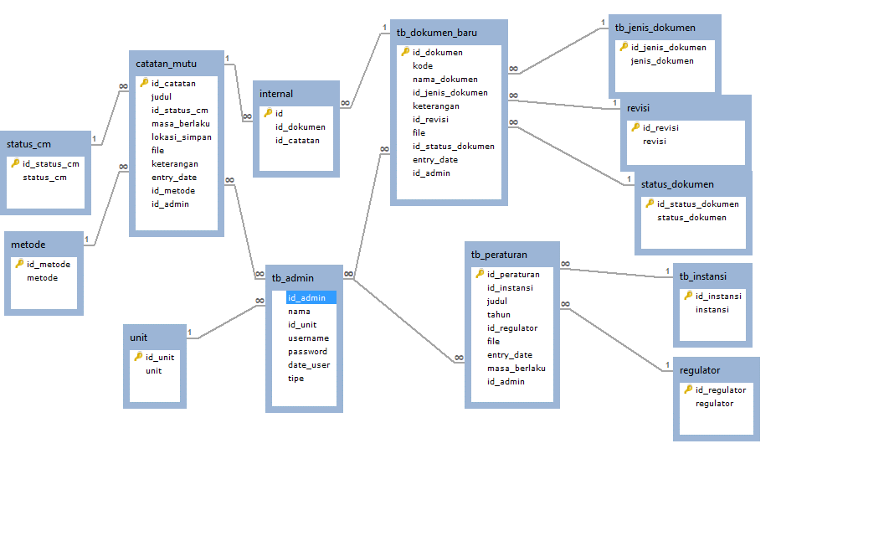

Figure 5 Database Design

F

Annotation:

*Catatan Mutu :* Support Document

*tb_dokumen_baru :* New Internal Document

*tb_peraturan* : External Document

*internal* : Linked Document

*status_cm* : Support Document Status

*metode* : Support Document Method

*unit* : Employees Division

*tb_admin*  : Admin Table

*regulator* : External Document Category

*tb_instansi* : External Document Agency Responsible

*tb_jenis_dokumen* : Internal Document Category

*revisi* : Internal Document Revision Number

*status_dokumen* : Internal Document Status

## **4.5 Web Structural Design**

### **4.5.1 User side**

Figure 6 User Web Structural Design

### **4.5.2 Admin Side**

Figure 7 Admin Web Structural Design

## **4.6 Interface Design**

Login Form for Admin and User

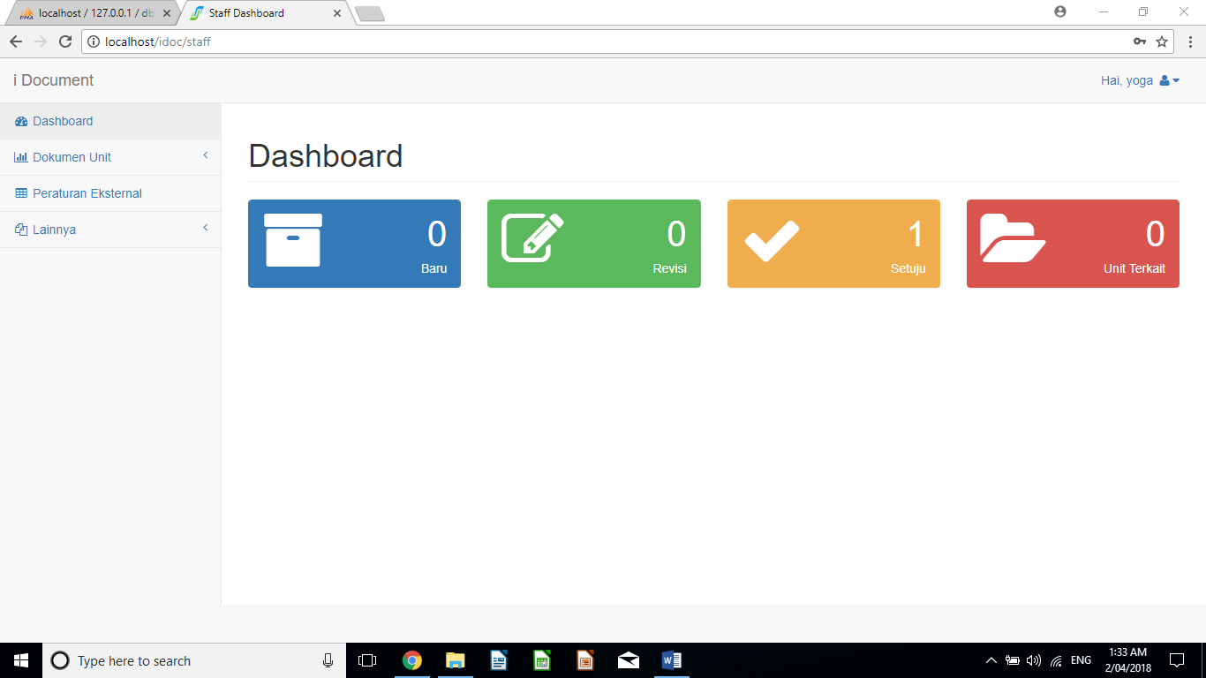

Figure 8 User Interface Design

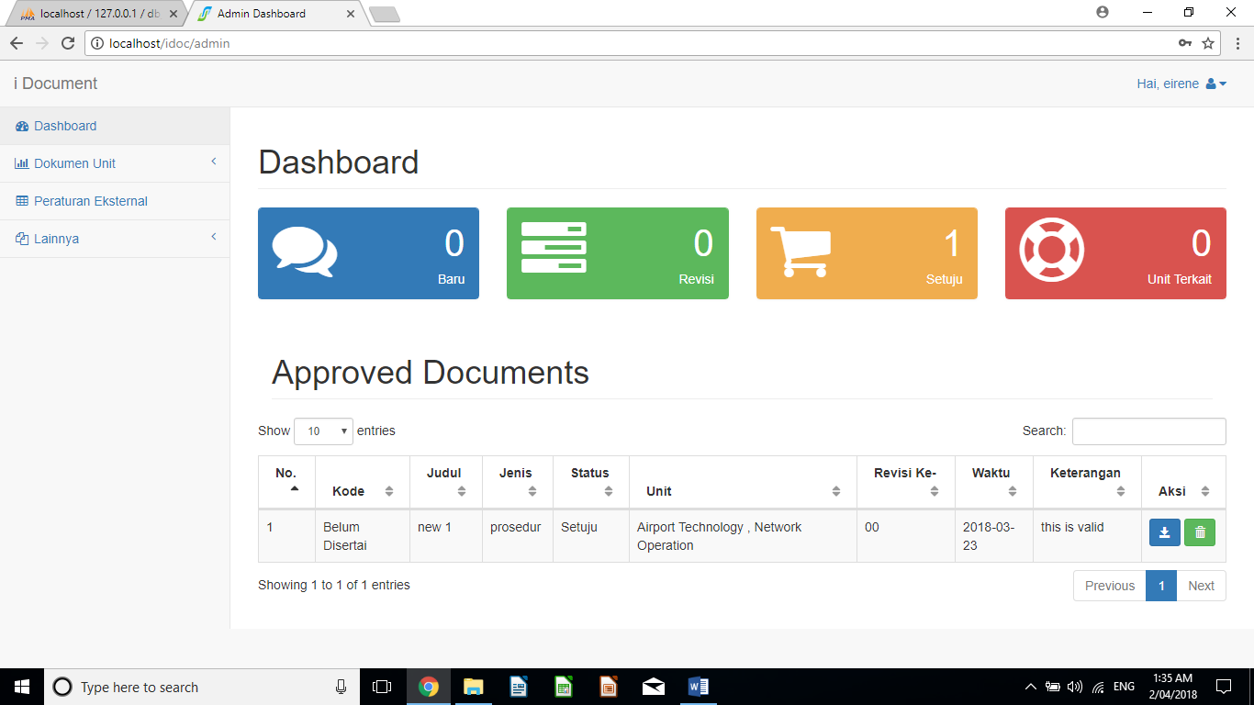

Figure 9 Admin Interface Design

# **CHAPTER 5: ITERATIONS**

### **5.1 Introduction**

We do not need significant iteration at this stage in BIT304 because previously one of our member team has develop kind of a prototype, However there are many shortcomings in the development including:

- The application Front-End was less feasible

- The application Backend system in our opinion was not too safe

- The application Backend framework using was still used a procedural PHP.

For this iteration we have plan for the upcoming BIT305. The iteration we need as much as 1 (one) time. With the planning as follows.

Table 23 Iteration Plan

|  |  |  |  |
| --- | --- | --- | --- |
| Iteration | Use Cases | Proposed Start Date | Proposed End Date |
| 1 | 1, 2 , 3, 7 and 8 | 1st March 2018 | 17th March 2018 |

### **5.2 Iteration 1**

### **5.2.1 Introduction**

The goal for the iteration is to make sure that between admin functional requirement and user functional requirement integrated well especially in displaying the document status. The user and admin can see the existing status document that stored in the system at the same time

### **5.2.2 Purpose**

The completion of an iteration comprises some defined portions of a phase. The completion of a phase is a milestone. The iteration for our project to be done when we enter the technical coding phase so if we found some errors or bugs we iterate the process only from technical coding phase not from the beginning.

### **5.2.3 Context**

The iteration plan fit when we find an errors or bugs on the system while we doing technical coding phase. So if there are some errors we must not iterate them from the very beginning but only from technical coding phase.

### **5.2.4 Schedule of Iteration Workflows**

Table 24 Schedule of Iteration Workflow

|  |  |  |  |
| --- | --- | --- | --- |
| Workflow | Start Date | End Date | Duration (days) |
| Use Case 1: Create/Re submit Document  (admin’s side and user’s side) | 8/3/2018 | 8/3/2018 | 1 |
| Design | 8/3/2018 | 8/3/2018 | 1 |
| Use Case 2: Edit Documents  (Admin’s Side and User’s side) |  |  |  |
| Design | 9/3/2018 | 9/3/2018 | 1 |

### **5.2.5 Iteration Schedule Breakdown**

Table 25 Iteration Schedule Breakdown

|  |  |  |  |
| --- | --- | --- | --- |
| Task Name | Start | Finish | Assigned To |
| Analysis | | | |
| Requirement Analysis | 21st February 2018 | 21st February 2018 | Aufar |
| Design &  Implementation |  |  |  |
| Redesign database | 21st February 2018 | 22nd February 2018 | Aufar |
| Redesign back-end | 23rd February 2018 | 28th February 2018 | Yoga |
| Redesign front-end | 1st March 2018 | 6th March 2018 | Yoga |
| Testing |  |  |  |
| Integration Testing | 7th March 2018 | 7th March 2018 | Yoga |

### **5.2.6 Resource Summary**

Table 26 Resource Summary

|  |  |  |  |
| --- | --- | --- | --- |
| No | Resources | Usage | Quantity |
| Hardware | | | |
| 1 | Laptop  (Windows 10) | Development of web application | 1 computers |
| Software | | | |
| 2 | Xampp Apache Server | Use to testing the iteration | 1 platform |
| 3 | Sublime Text 3 | Use to write code | 1 platform |
| 4 | Web Browser | Use to test the iteration on the web browser | 2 Browser |

### **5.2.7 Evaluation Criteria**

The form to input an attachment of a document to the system and edit must be integrated form each other. When the user has already inputed the document data and uploaded the document as an attachment of the document itself it must be shown on the dashboard page on the system the details of the documents like number, document name, category, date, and who uploaded it. The system must have download link so the user or admin can download the document on the system before they want to update it and re submit it again to the system.

### **5.2.8 Analysis and Design Artefacts**

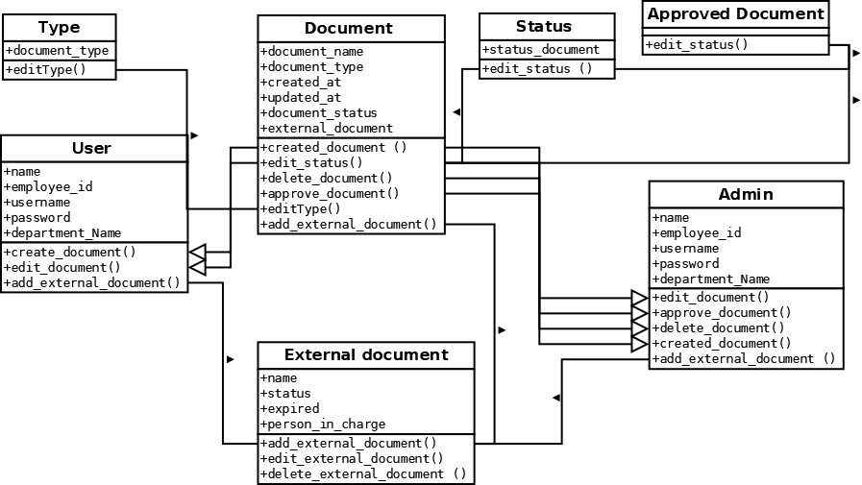

Figure 10 Class Diagram

From the class diagram above we have shown that admin and user both can edit or upload document to the system. But only admin can delete the documents on the system.

### **5.3 Implementation and Testing**

#### **5.3.1 Implementation**

The tools that we used to test the system is web browser and XAMPP software to test the system. Because it is implemented on the web based platform, before we deploy it, globally first we must test it on the local server with XAMPP Apache Server Software.

#### **5.3.2 Testing**

Here is our Test Evaluation Report that was the result of testing of the system.

Table 27 Test Evaluation Report

|  |  |  |  |  |  |
| --- | --- | --- | --- | --- | --- |
| **No** | **Functional**  **/Non Functional**  **Requirement** | **Unit**  **Testing** | **Integration Testing** | **Performance**  **Testing** | **User Acceptance**  **Testing** |
| **Functional (User and Admin side)**  ✓= Available  🗶= Not Available | | | | | |
| 1 | Submit /Create Document | ✓ | ✓ | ✓ | ✓ |
| 2 | Edit Document | ✓ | ✓ | ✓ | ✓ |
| 3 | Delete document | ✓ | ✓ | ✓ | ✓ |
| 4 | Approving Document | ✓ | ✓ | ✓ | ✓ |
| 5 | Registration account | ✓ | ✓ | ✓ | ✓ |
| 6 | Edit User / Admin profile account | ✓ | ✓ | ✓ | ✓ |
| 7 | Login | ✓ | ✓ | ✓ | ✓ |
| 8 | Log out | ✓ | ✓ | ✓ | ✓ |
| 9 | submit external document | ✓ | ✓ | ✓ | ✓ |
| 10 | Document Sorting as document type | ✓ | ✓ | ✓ | ✓ |
| 11 | Make document report to format | ✓ | ✓ | ✓ | ✓ |
| **Non Functional (User and Admin side)** | | | | | |
| **Non Functional requirement** | | **Available or not?**  **✓= Available**  **🗶= Not Available** | | | |
| 1 | Availability | ✓ | | | |
| 2 | Maintainability | ✓ | | | |
| 3 | Testability | 🗶 | | | |
| 4 | Integrity | ✓ | | | |

Here is the screenshots of each module that already worked successfully in the system. The screenshot also will shown the process from the user submit the document until the document itself is stated valid by admin.

Additional information

**Browser used :**  Google Chrome

**Web Server Used :** Apache

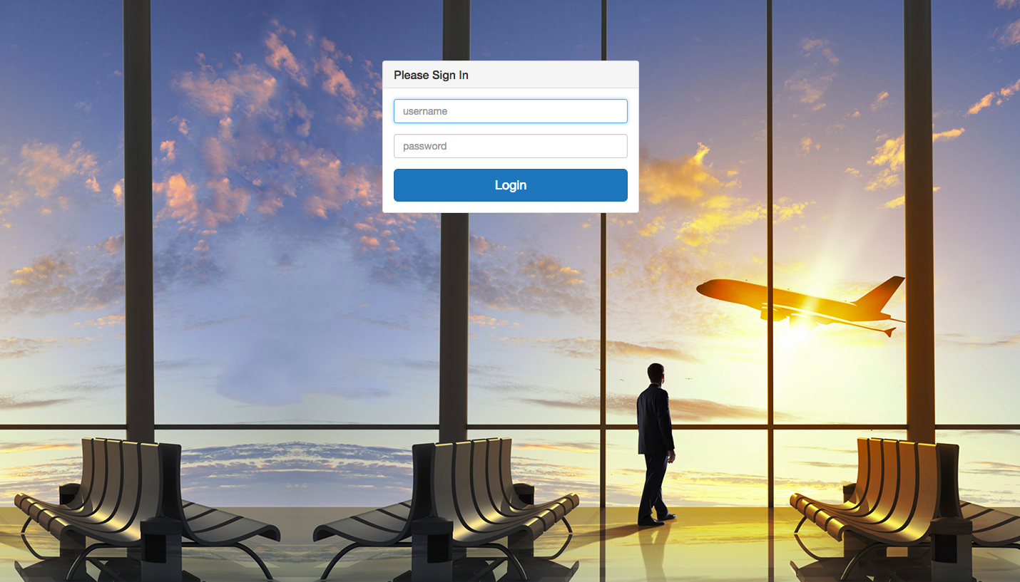

Figure 11 Admin and User Login Page

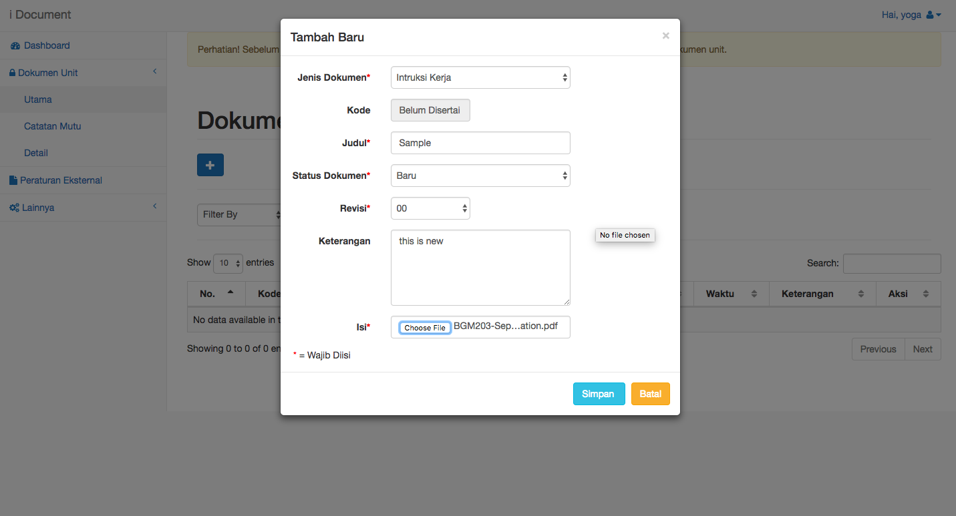

Figure 12 User Submission Form

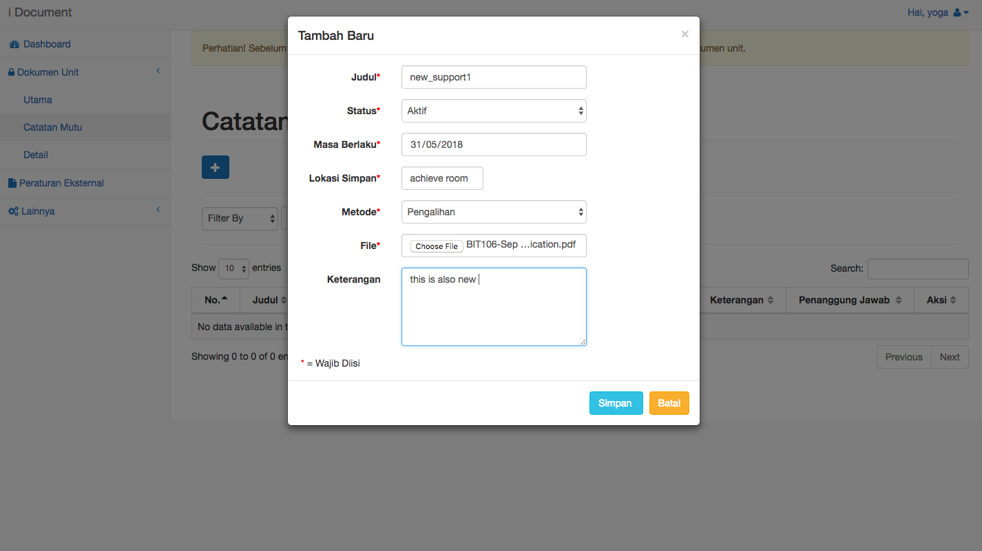

Figure 13 User Fill the Support Document Form

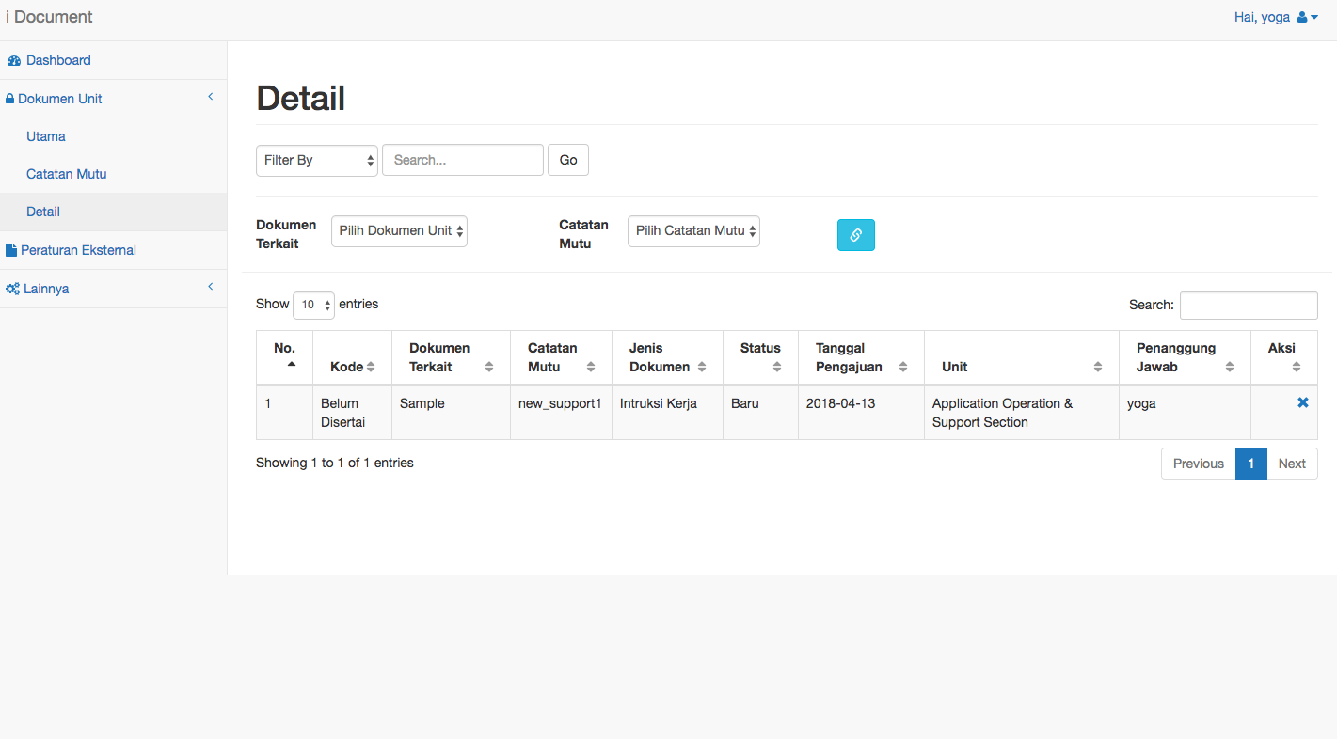

Figure 14 Detail Document Page

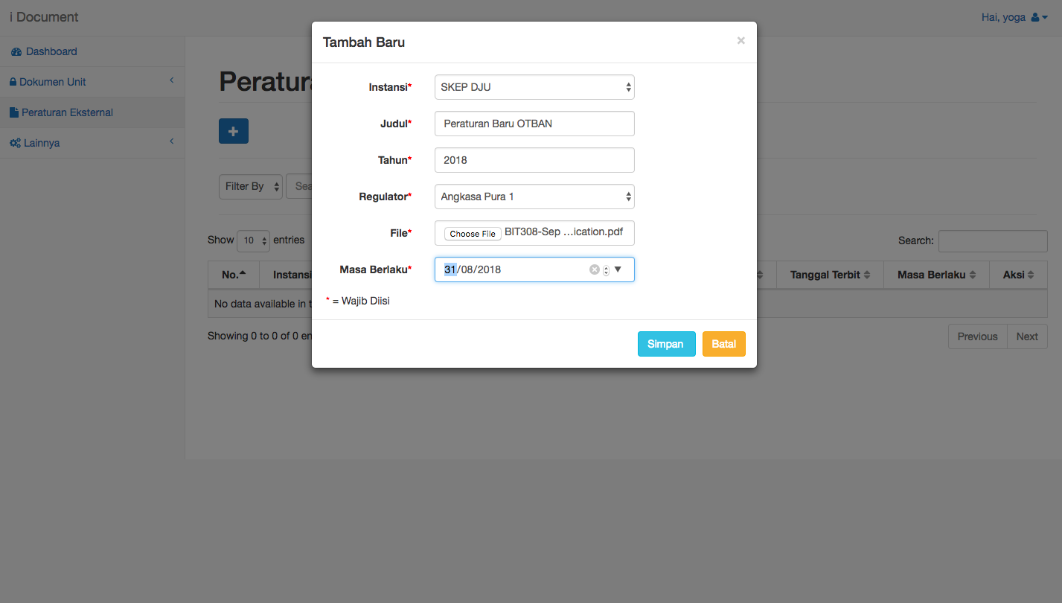

Figure 15 User Fill the External Document Submission Form

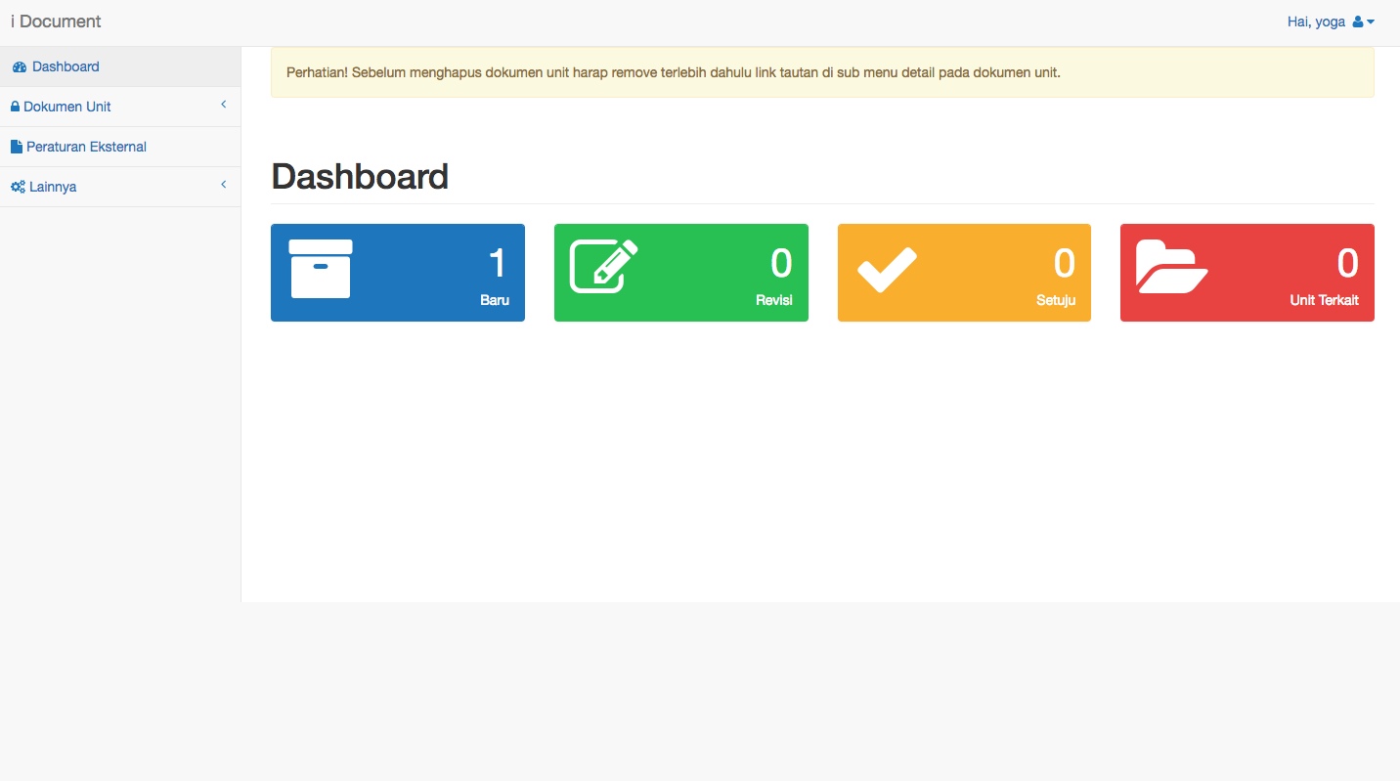

Figure 16 User Dashboard Page

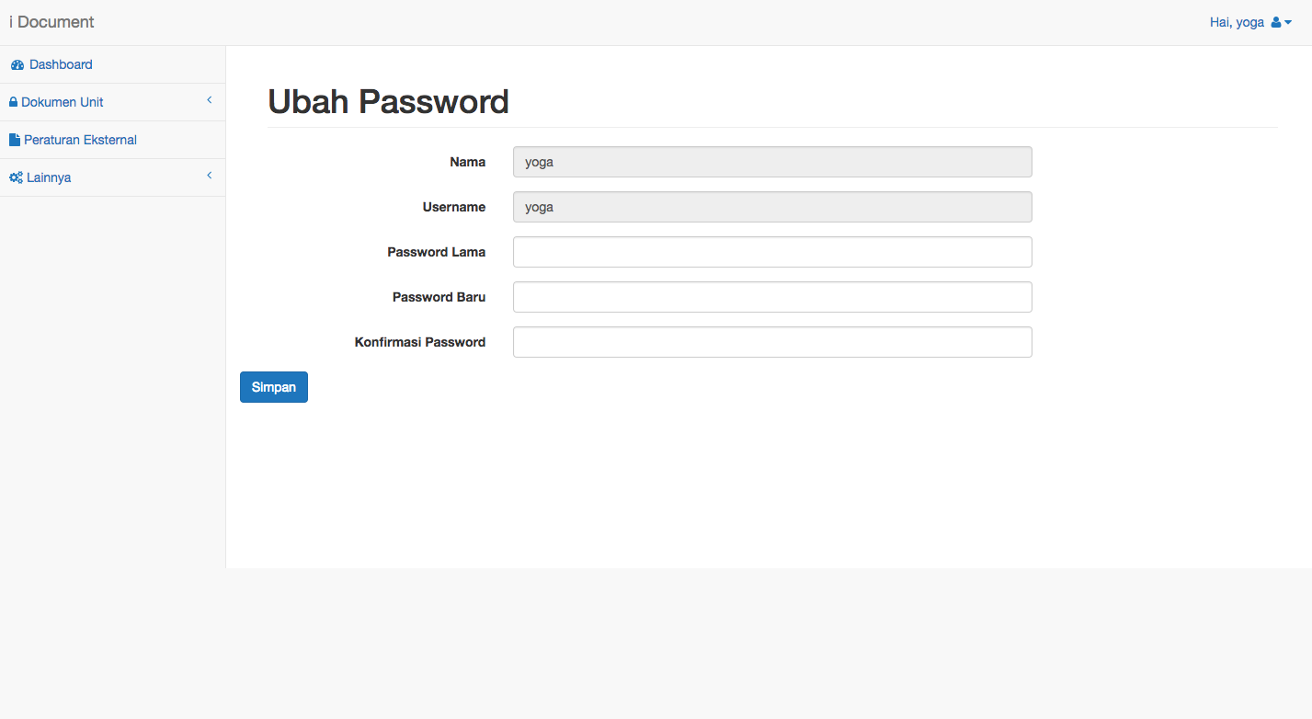

Figure 17 User Change Password Page

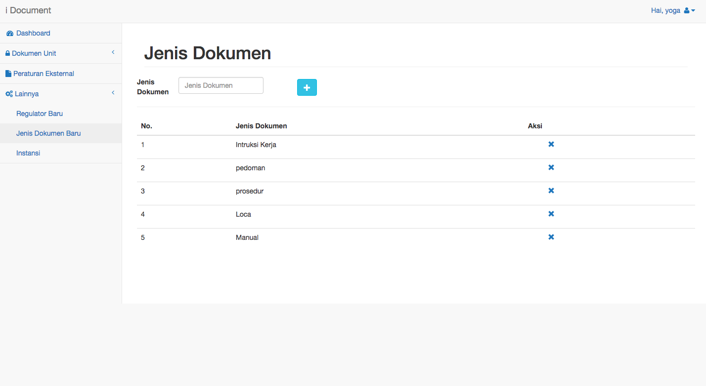

Figure 18 Add Document Category Page

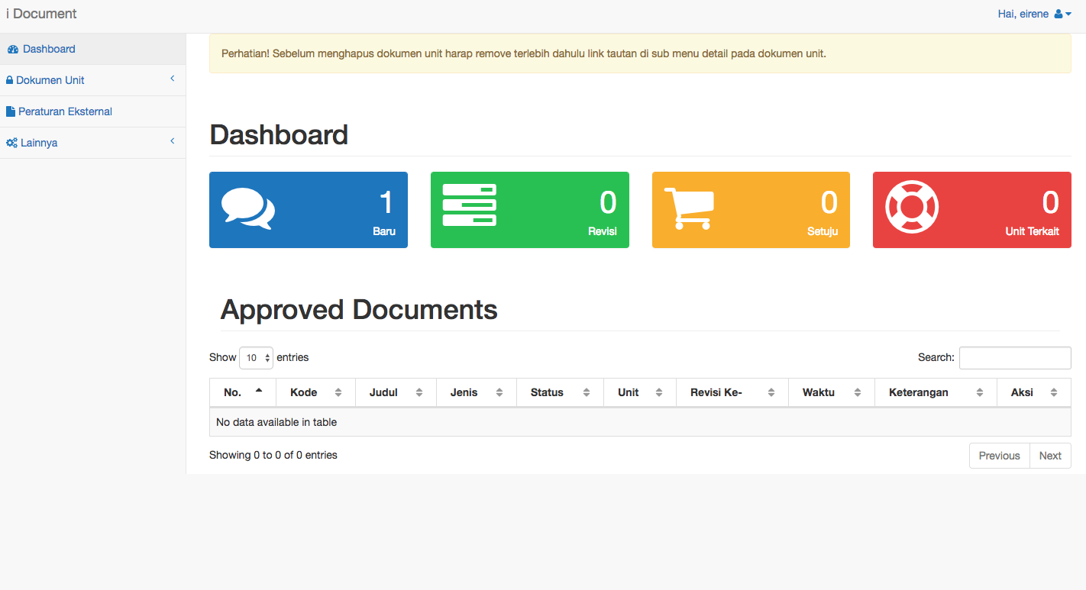

Figure 19 Admin Dashboard

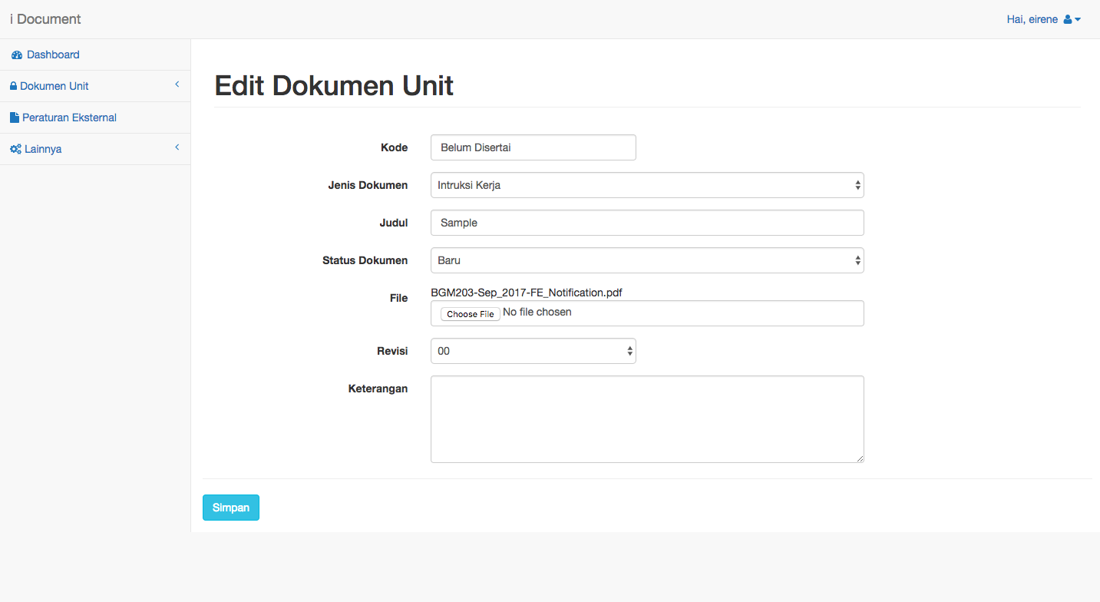

Figure 20 Admin Edit Document Form

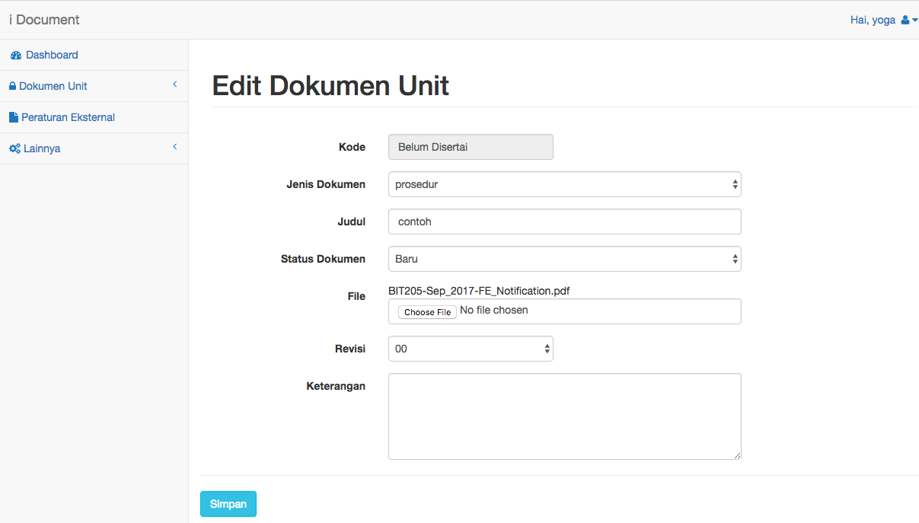

Figure 21 User Edit Document Form

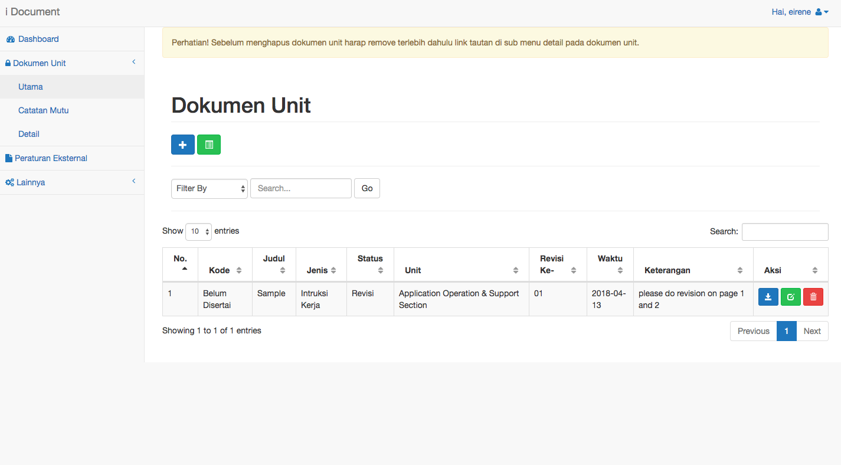

Figure 22 Document Successfully Updated

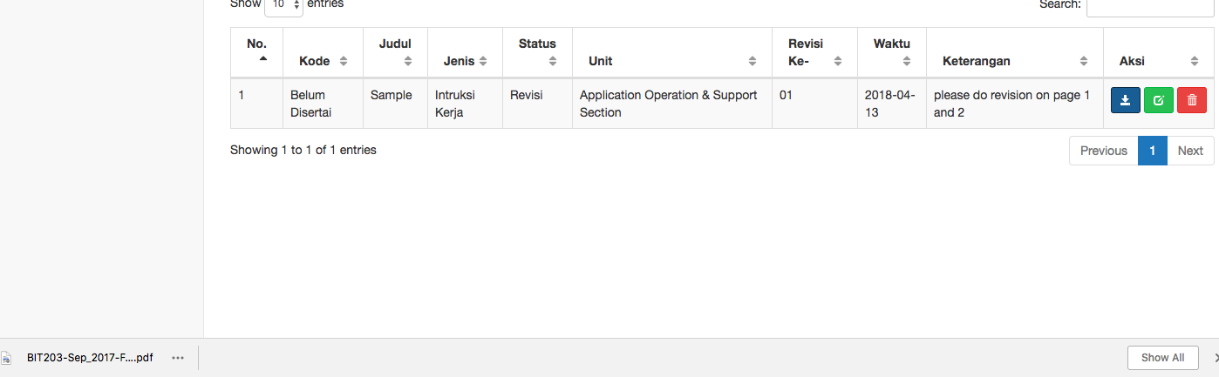

Figure 23 User And Admin Successfully Download Document Out From the System

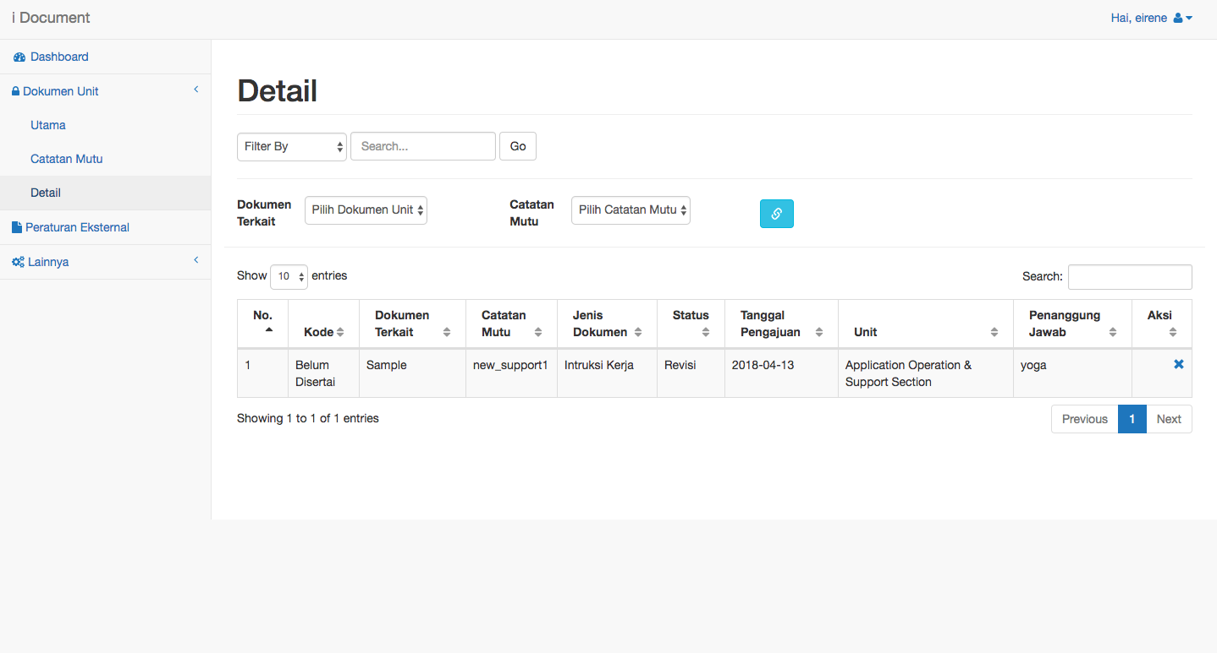

Figure 24 Document Detail Page Between Internal Documents and Support Documents

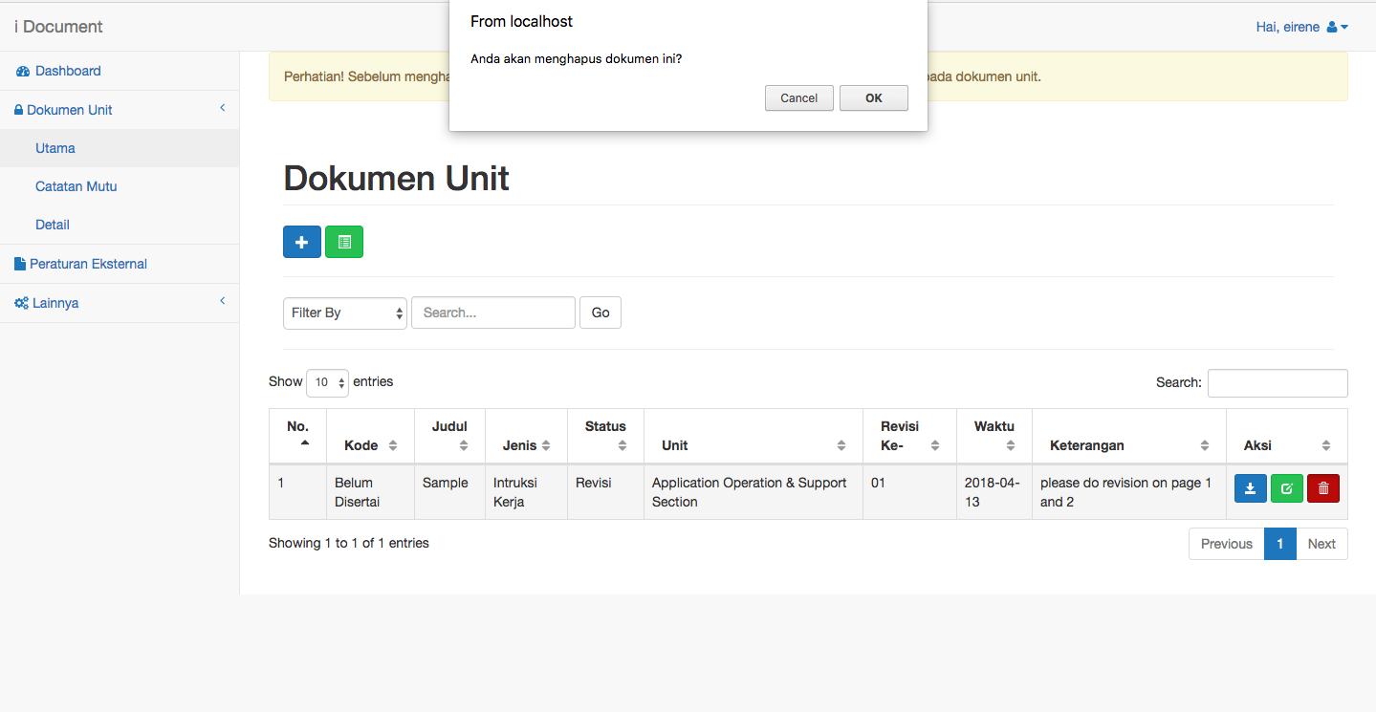

Figure 25 An Alert When Admin When Press Delete a Document

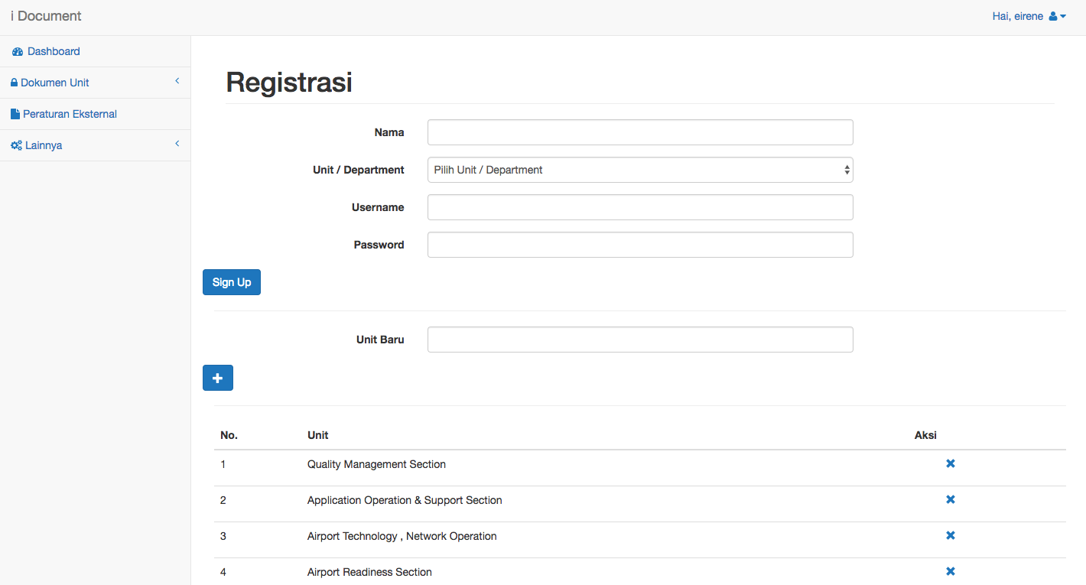

Figure 26 Registration Page

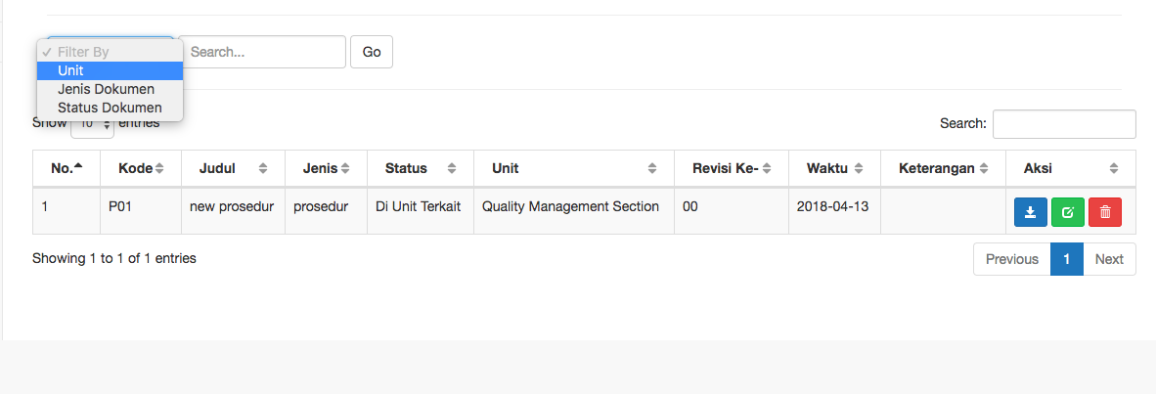

Figure 27 Sorting Documents

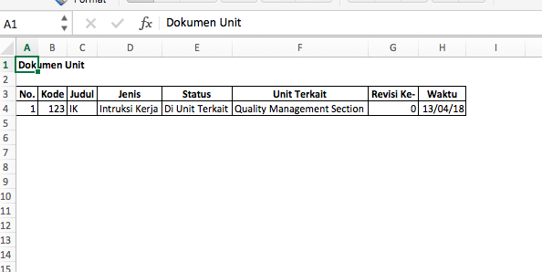

Figure 28 Internal Document Report

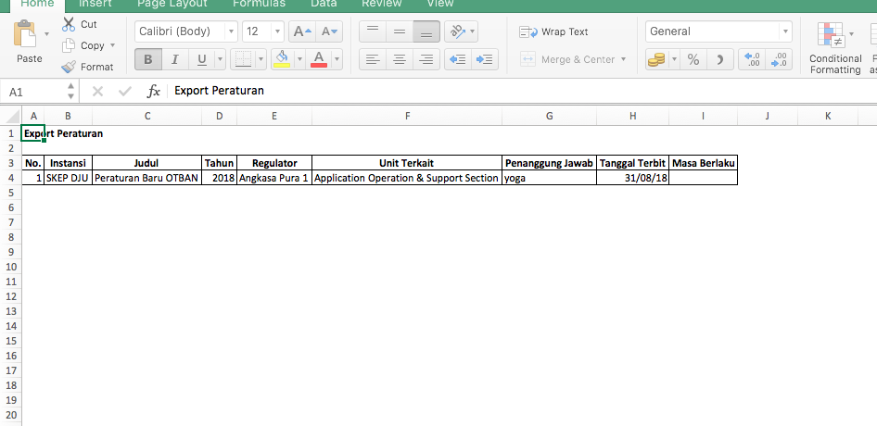

Figure 29 External Documents Report

### **5.4 Iteration Review and Evaluation**

Overall the system could running well so far. We have done the iterations on schedule but know until this iteration review is written, there was only 1 (one) functional requirement left that has not been completed yet. We must make sure all requirements that expected by the company are completed without bugs and errors inside it. And we must make sure the system are secure because it is implemented base on the web application and store many important documents inside the database.

The document report internal and external is not really in a right form because we did not know yet the actual form of the report so that is the temporary report form until we could communicate with the staff of Angkasa Pura I to discuss about the actual form of the report

# **CHAPTER 6: CONCLUSION**

## **6.1 Introduction**

Until the writing of this conclusion the system was which partially completed all functional requirements was meet the company expectation because we did white-box testing with one of their staff in this company. The result of the testing has been attached in this report.

## **6.2** **Further Improvement**

Generally the system was completed. All functional requirements was fulfilled. We did not know what kind of improvement next to the system that we proposed here because we had done all requirements of the system. The system will be given directly by Angkasa Pura I ICT staff. So for the next improvement of this application will be their own responsibility. But we had ensure that the system coding is maintainable to make their ICT staff easy to improve the system in the future.

## **6.3 Future Work**

The future work that we must do next is that we will make the infographic and manual book for the application. Maybe the staff in this company soon need us again to train the user of all employees in the company about how to use the system.

## **6.4 Project Evaluation**

### From : Yoga Permana Tanaya / E1400464

Overall our project meet the initial aims that we settled before. The system can store all the documents correctly and can sort the documents to find a specific document if there was too many inside the system. The modification that we have made was from the database design because we had some several revision from the company itself that give revision after they did many test to the system we made.

On the making of this project we face a problem in document report writing but that did not give effect to our schedule. We still on the track of this project. When this project evaluation is written we still waiting confirmation from the Angkasa Pura I Company staff because they were still doing several testing to our system we made in their environment and their user acceptance. Maybe a week later we will receive the testing report from them. Here was the burndown gantt chart of our project.



Figure 29 Burndown Gantt Chart

What went right? The way that make us easier making this project is one of our member has been develop a kind of system like this so we only use the existing project and reuse the application back-end and database design to save a lot of time.

What went wrong? We did not know how to write the scientific document report properly so we face a problem when the BIT304 (FP1) document got some problem. So we must re writing the document. Luckily when that was happened the project is nearly done so we still had time to re write the document of BIT304 (FP1).

From the problem we faced above we have learnt something that we must learn how to write paper / scientific document properly not just too focus on coding the system itself.

This project is not an economic project because this project goal was only to solve the problem of achieving in Angkasa Pura I Company. So we got benefit each other the company got the suitable application. And we got the challenging experience to make the web application for a big national company like Angkasa Pura I Company.

### From : Aufar Rahman / E1200241

It was going very well, there was nothing changed from the original aim because it was very clear what the company want us to make for them. The Document need to be more checked for any mistake. We did not just rely on Google Translate. Since I did not have much experience with coding a program, I rely heavily on my other member to do that part, while I help with writing and edit the document.

# **Bibliography**

Angkasa Pura 1. (n.d.). *AngkasaPura Airports* . (AngkasaPura Airports ) Retrieved from AngkasaPura Airports : https://www.ap1.co.id/id/about/our-history

Kenny, E. (2017). *SISTEM PENYEDIAAN DOKUMEN INTERNAL DAN EKSTERNAL .* Badung: Angkasa Pura I Persero .

Beynon-Davies, P. C. (1999). Rapid application development (RAD): an empirical review. *European Journal of Information Systems*, 211-223.

R Lerdorf, K. T. (2006). *Programming Php.* O'Reilly Media, Inc.

Das, R. S. (2016). Comparison of Procedural PHP with Codeigniter and Laravel Framework. *International Journal of Current Trends in Engineering & Research*, 2(6).

Dubois, P. (2003). *MySQL: the definitive guide to using, programming, and administering MySQL 4.* Sams.

*Definition - What Does Structured Query Language (SQL) mean?* (n.d.). Retrieved from techopedia : https://www.techopedia.com/definition/1245/structured-query-language-sql

Oracle. (n.d.). *About MySQL*. Retrieved from MySQL: https://www.mysql.com/about/

APACHE. (n.d.). Retrieved from APACHE HTTP SERVER PROJECT.

Kenny , E. (n.d.). SISTEM PENYEDIAAN DOKUMEN INTERNAL DAN EKSTERNAL . Badung, Bali, Indonesia .

## **APPENDIX A: GANTT CHART**

## 

## **APPENDIX B: PROGRESS REPORTS**



**WEB BASED DOCUMENT CONTROL SYSTEM**

**BIT305**

**Final Year Project II**

**MARCH - 2018**

**MONTHLY PROJECT PROGRESS REPORT**

**1. PROJECT TITLE**

Web Based Document Control System .

**2. STUDENT NAMES**

1) Yoga Permana Tanaya (E1400464)

2) Aufar Rahman (E1200241)

**3. PERIOD COVERED**

12/3/2018 to 24/3/2018

**4. KEY ACCOMPLISHMENTS**

Complete all functional & non functional requirement in the system.

**5. PROJECT STATUS**

Mark as appropriate: on schedule ahead behind

✓

**6. ISSUES/CONCERNS**

We were doing testing with the stakeholder that involved directly in this project. Angkasa Pura I Company as our customer. Issues that might happened when complete this project was communication because we were doing it by only via online chatting with one of their staff. And also the database design which we need to design several times to fulfill the requirement given by our customer

**7. Signatures**

Student Names: Yoga Permana Tanaya

Date: 3/24/2018

Student Names Aufar Rahman

Date: 3/24/2018

Gantt Chart

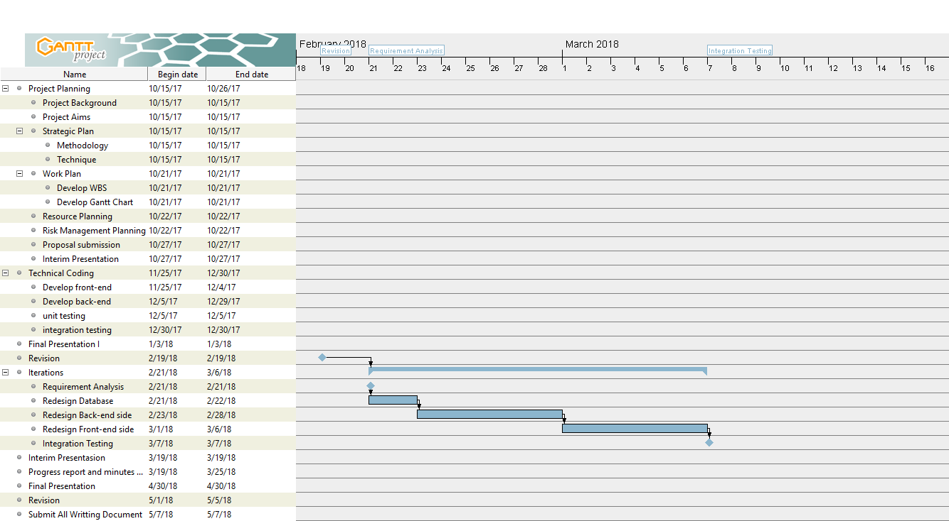

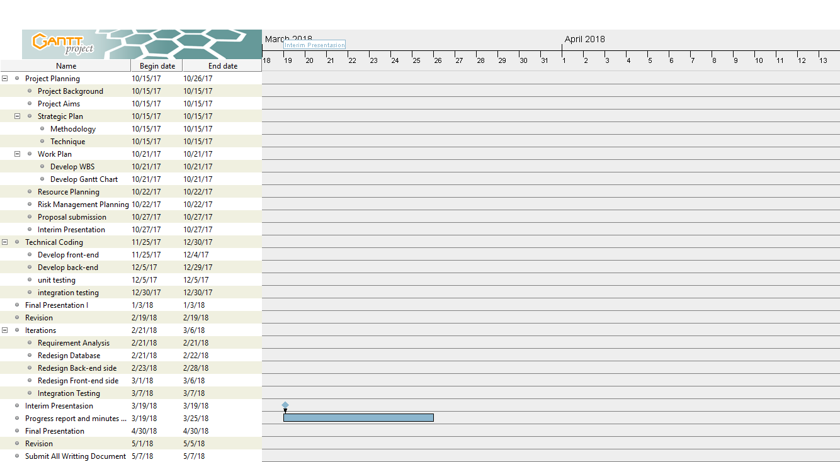

**APPENDIX C: MINUTES OF MEETINGS**

BIT305 Final Year Project II

Web Based Document Control System

Minutes No. I

Date : February, 22nd 2018

Time : 3 PM (Central Indonesia Time)

Venue : Colony Creative Hub.

**Present :**

Yoga Permana Tanaya : Project Manager

Aufar Rahman : Secretary

|  |  |  |
| --- | --- | --- |
| **No.** | **Matters Discussed** | **Action By** |
| 1.0 | Proposal | Aufar Rahman |
| 1.1 | Introduction | Aufar Rahman |
| 1.2 | Company Background | Aufar Rahman |
| 1.3 | Project Description | Aufar Rahman |
| 1.4 | Project Aims | Aufar Rahman |
| 1.5 | Software and Hardware Requirement | Aufar Rahman |
| 2.0 | Literature Review | Yoga Permana Tanaya |

**Minuted by:** Aufar Rahman

**Verified by:** Yoga Permana Tanaya

## **APPENDIX E: SYSTEM SUBMISSION**

### **E.1 DVD**

### **E.2 Installation Instructions**

Follow these steps to deploy this web on a local server:

1. Copy the “idoc” folder. That folder is the folder of the project itself
2. Open the browser Chrome or Mozilla Firefox
3. Type localhost/phpmyadmin on URL in the browser
4. Import “*db_bandara.sql*” file. The file of the database of the system
5. Click Save
6. Now type in another tab in the browser

localhost/idoc

1. Your application is ready to be used on a local server

1. **Yoga is responsible for producing this high level use case.**
2. **Yoga is responsible for producing this high level use case.**
3. **Aufar is responsible for producing this high level use case.**
4. **Yoga is responsible for producing this high level use case.**
5. **Yoga is responsible for producing this high level use case.**
6. **Aufar is responsible for producing this high level use case.**
7. **Yoga is responsible for producing this high level use case.**
8. **Yoga is responsible for producing this high level use case.**
9. **Yoga is responsible for producing this high level use case.**
10. **Yoga is responsible for producing this high level use case.**
11. **Yoga is responsible for producing this high level use case.**
12. **Yoga is responsible for producing this high level use case.**
13. **Aufar is responsible for producing this high level use case.**
14. **Aufar is responsible for producing this high level use case.**
15. **Aufar is responsible for producing this high level use case.**
16. **Yoga is responsible for producing this high level use case.**
17. **Yoga is responsible for producing this high level use case.**
18. **Yoga is responsible for producing this high level use case.**